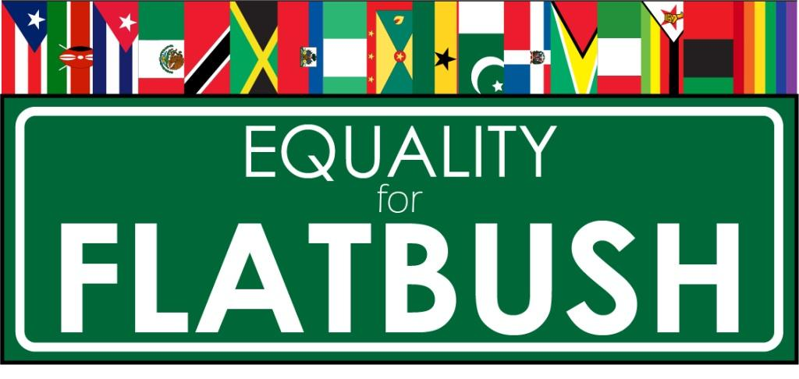
Equality for Flatbush (E4F)’s Suggestions & Tactics as an Alternative to Calling 911
https://bit.ly/AltTo911Paper
Released: August 9, 2017
Updated: April 26, 2019
Created in consultation with Anna Ortega-Williams, Phd, LMSW; Luke Peng-Patterson, LMSW ; and Imani Henry, MSW, MPA of the Radical Social Work Group.
PoliceWork@equalityforflatbush.org or 646.342.9673

www.equalityforflatbush.org

The NYPD is required to respond to 911 calls, including those for medical and mental health emergencies. Unfortunately, the murders of Mohamed Bah, Deborah Danner, Dwanye Jeune, and Saheed Vassell along with the near-death shooting of Davonte Pressley, demonstrate how calling 911 can result in the murder or brutalization of a community member or loved one. Police officers are not trained to handle mental health or medical crises, and statistically close to 50% of all police murders in the US involve a person living with a physical disability or mental health condition.

Historically, young people, homeless people, people of color, migrants/immigrants, women, LGBTQ people, and people living with mental health/cognitive conditions or physical disabilities, are all groups who experience high rates of profiling and police violence. This is especially important, given it is a widely-held societal belief that people should call the police if they are involved in a dispute with a neighbor or family member. There are numerous examples in NYC and nationally where an 911 call over an interpersonal dispute has resulted in a police murder or violence.

It is also widely documented about the increase in police presence, harassment and violence in rapidly gentrifying neighborhoods of color. One alarming aspect of gentrification has been the increase nationally in the number of both 911 and 311 calls made by newer and/or white residents living in historically low-to-middle income communities of color .

For all these reasons, Equality for Flatbush (E4F) wants to provide community members with suggestions and tactics to use if you do NOT feel like calling 911 is a SAFE or APPROPRIATE option for you. Also please feel free to utilize Equality for Flatbush, as a resource. E4F is part of social work, cop watch, and violence-interrupter networks. Please contact us at : PoliceWork@equalityforflatbush.org or 646.820-6039

- GET INVOLVED with your Community / Neighborhood Group or your Tenant / Block Association: Studies have shown that strong cohesive communities help to deter crime and gun violence. The more we get to know our neighbors, the more trust is created within a community. Within our own neighborhoods, buildings, and communities are people we can call upon to help us navigate times of crisis or need. There are countless examples of the ways people have intervened and provided support or resources for mental health, medical, domestic/interpersonal violence and other crises to each other. Now is the perfect time to assess, identify and create crisis intervention resource lists for yourself and neighbors. The more self-reliant we become as a community to create solutions and resolve issues, the less likely we will be to turn to the police.

- JOIN A COP WATCH TEAM: Cop watching is a tactic to document police interactions in our community as well as make sure community members have access to legal and political resources. Cop watching has helped to both deter police violence and provide community members with video to use in court. If you are 18 years or older and a person of color, and you want to be trained to cop watch in your neighborhood, please contact The Justice Committee at info@justicecommittee.org. Equality for Flatbush: E4F is a proud member of the People’s Justice for Community Control and Police Accountability East Flatbush Cop Watch Team.

- CALL on your NEIGHBORS or COMMUNITY LEADERS to INTERVENE or MEDIATE BEFORE a SITUATION ESCALATES: Many landlords tell tenants who have disputes with their neighbors to call the police on each other. There is also a common belief that the police will simply come "and teach a lesson" to a difficult family member. So often, we are just too afraid to reach out and ask for help before things get worse. It is important that we find alternatives to calling the police for family, tenant or community disputes. Can a neighbor, tenant association, or community leader be asked to mediate instead of calling the police? Can you OFFER YOURSELF as a MEDIATOR within your neighborhood, building or community? Again, the more self-reliant we become as a community to create solutions and resolve issues, the less reliant we are on the police.

- Get trained in Mental Health First Aid! Learn what you can do to support yourself, family, and community if there are signs of escalating mental health needs. Get certified and train your family and neighbors to all be Mental Health First Aiders, knowledgeable about how to respond to mental health needs and destigmatize getting help. It’s free to get trained or become a trainer.
For more info:

- ASK a MENTAL HEALTH or MEDICAL CARE WORKER to assess if 911 is even needed: Depending on the circumstances of your situation, a mental health or medical care worker may be able to assess whether a loved one or community member needs emergency assistance. Call 1-888-NYC-WELL or text WELL to 65173 to get immediate mental health support 24 hours a day, 7 days a week. In many cases, a trained professional mental health counselor or medical care worker may be able to intervene and assist with getting the community member or loved one the proper care without calling 911. One question you can ask is: Are you in a position to take a cab to the hospital or mental health care facility with your loved one or the community member instead of calling an ambulance?

If you absolutely must call 911, then consider having a mental health or medical provider present to advocate on the behalf of a community member or loved one with the police and EMS workers. If YOU are a MENTAL HEALTH or MEDICAL WORKER, can you be available to intervene before, during and after 911 calls are made?

TACTICS FOR IF YOU HAVE TO CALL for 911 EMERGENCIES

Here are some suggestions of what to say or do to try to control and deescalate the situation as best as you can:

1. Tell the 911 OPERATOR that “IT IS A MEDICAL EMERGENCY AND I NEED AN AMBULANCE.” Mental health emergencies legally fall under the category of medical emergencies. On the call, carefully describe the physical issues going on for your loved one or community member.

2. Reach out & gather other community members &/or your local copwatch team to support you when the 1st responders arrive. If it seems necessary or appropriate film/ record the encounter with the police/EMS.

3. If you can, go out and meet the police or 1st responders before they encounter the community member or loved one. Continue to say that it is a MEDICAL EMERGENCY & that you need an AMBULANCE, especially if the police arrive first. Make sure you're calm when interfacing with the police, so that in whatever way possible you are able to make your presence unthreatening.

4. If it is safe and ok with the community member or loved one for you to accompany them to the ER, please consider doing so.

Equality for Flatbush (E4F) is a Black/POC-led, grassroots organization which does police accountability, affordable housing and anti-gentrification/anti-displacement organizing in Brooklyn, NY , especially in the neighborhoods of Crown Heights, East Flatbush, and Flatbush. Founded in June 2013, E4F is a Black Lives Matter (BLM) group that believes in the abolition of the police, U.S. Immigration and Customs Enforcement (ICE), and prisons. Created as a direct response to the increase in tenant and police harassment due to gentrification, we have only two goals: to end NYPD murders and to stop the displacement of low and middle income people from Brooklyn, NY. We organize our communities for social change and justice through street outreach, social media campaigns, as well as political and direct action.

