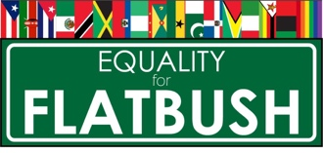

Equality for Flatbush’s DO NOT Call List of Predatory Private Lawyers
As of November 2021

The following is a list of lawyers that have been identified by tenants, activists, community members and other attorneys as predatory, untrustworthy, lacking the cultural competence to work communities of color, and / or profiting from the misfortune of others. If you feel you have been exploited or taken advantage by a private attorney please contact Equality for Flatbush at b4g@equalityforflatbush.org or 646-820-6039

Criminal Attorneys

Joyce David
495 Flatbush Ave 2nd floor Brooklyn, NY 11225

Matthew D. Myers
Myers, Singer & Galiardo
299 Broadway Suite 200, New York, NY 10007

Civil Law & Real Estate Attorneys

Carl E. Person
225 E. 36th St - Suite 3A, NY NY 10016

Sharon Rainford
140 Broadway Fl 46 New York, NY 10005

Leonard W. Stewart
32 Court St Ste 707, Brooklyn, NY 11201

Mitchell Troyetsky
220 East 42nd Street, 25th Floor New York, New York 10017

Shellon O. Washington and Stephen Knights
Law Offices of Knights, Washington and Associates
2720 Farragut Road, Brooklyn, NY 11210-1436

Landlord/Tenant /Housing

David Harris
88-32 Sutphin Blvd. Jamaica, NY 11435

Joseph J. Lepelstat
323 Flatbush Ave, Brooklyn, NY 11217

