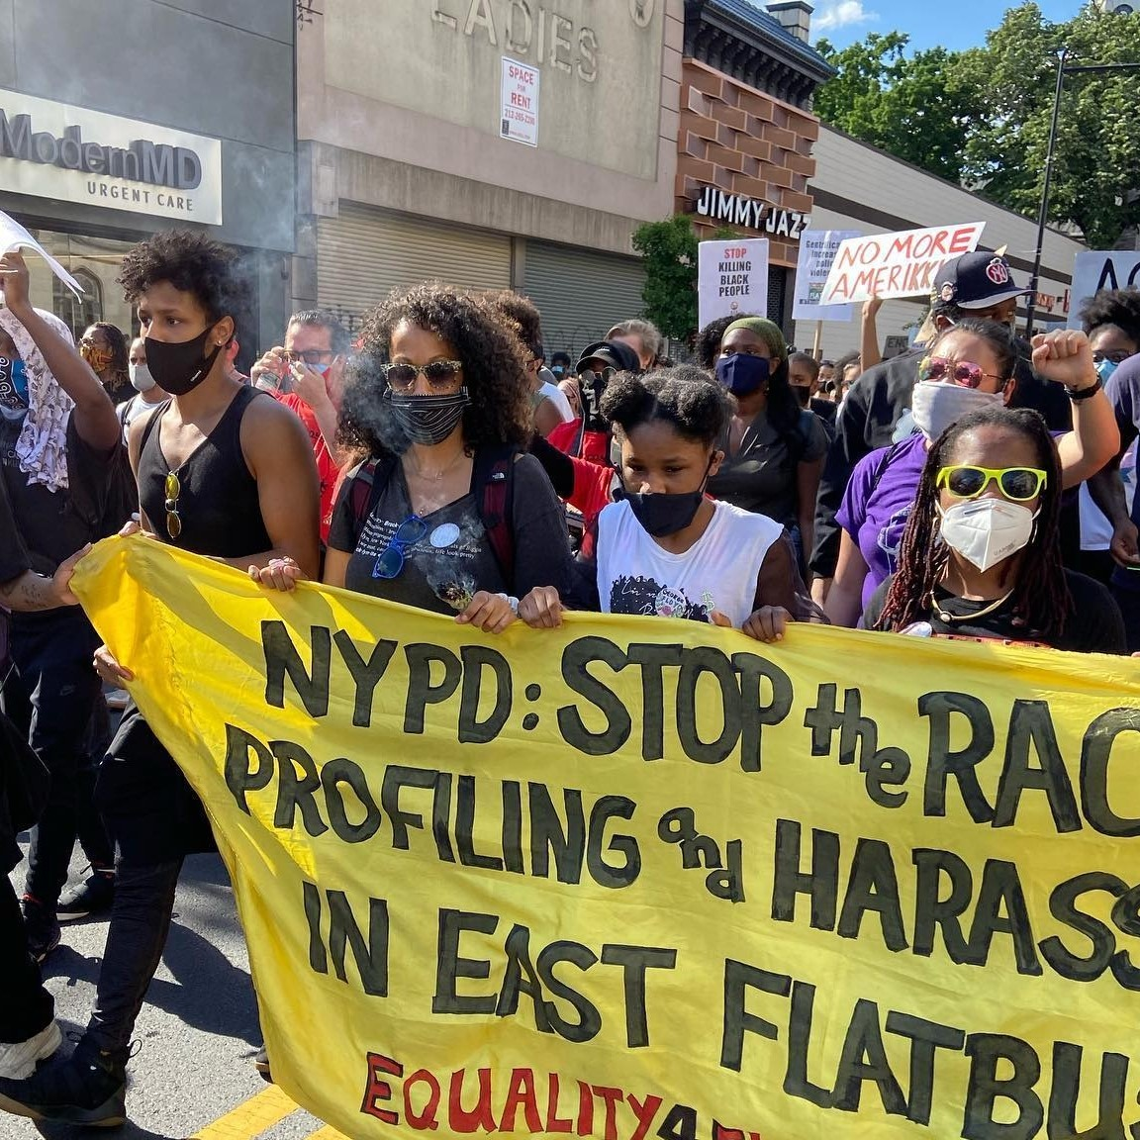
ABOUT E4F
Equality for Flatbush (E4F) is a Black/people of color-led, multi-national grassroots organization that does anti-police repression, affordable housing, and anti-gentrification/anti-displacement organizing in Flatbush, East Flatbush, and Brooklyn-wide. Equality for Flatbush has two goals: end NYPD murders and stop the displacement of low to middle-income people from our community. We organize our communities for social change and justice through street outreach, social media campaigns, political advocacy, and direct action. We believe in the self-determination and leadership of those most impacted by police violence and gentrification to create their own strategies for social change and justice.

JOB SUMMARY & KEY RESPONSIBILITIES
E4F seeks a Lead Organizer who is a seasoned manager, grassroots organizer, and strategist with a radically progressive political vision, commitment to people-led system change and significant experience in a people of color-led, member-driven grassroots organization. We want to grow our infrastructure in order to address COVID-19 and the crisis of violent police repression of communities of color. This existing position will direct the on-the-ground organizing and work closely with our grassroots leadership and executive director. E4F seeks someone who will thrive in a fast-paced work environment, coordinate direct actions, and facilitate processes of collective decision-making with partner groups/coalitions. This person should deeply embody our organizational principles of working from a place of revolutionary love and solidarity, fighting for justice, and the liberation of oppressed peoples. Key responsibilities include:
- Collaborate with leadership and member base to lead anti-displacement and anti-police repression campaigns, respond to new political developments, and develop multifaceted strategies.
- Strengthen & grow the community’s ongoing efforts to address the root causes of the systemic injustice.
- Launch, manage, and coordinate targeted campaigns and interventions.
- Coordinate with allied organizations, coalitions, city-wide anti-gentrification & police accountability campaigns
- Track progress and outcomes of organizing work, create and maintain administrative systems, and collaborate with development staff/consultants to provide information to current and prospective funders
- Represent and coordinate participation of members and activists on panels, speaking engagements, press interviews, etc.

QUALIFICATIONS
- 8-10 years’ experience in grassroots system change organizing with people of color-led, member-driven organizations.
- Knowledge of current NYC & national political landscape with deep understanding of: Black/Brown Lives Matter movements; migrant rights; ending violence & oppression of women/LGBTQ people, anti-police repression; affordable housing/ housing justice; the fight for low wage workers/street vendors; ending the school to prison-line, and anti-gentrification/anti-displacement.
- Commitment to building people power and bringing about radical change through community organizing.
- Ability to be forward-thinking, to balance our long-term vision for change with the immediate and changing needs of our community, to be accountable to the community, and to advance the work in meaningful ways.
- Fluency in languages spoken by a significant number of our members is a plus.

SALARY | $60,000 per year as a 1099 contractor, plus stipend for benefits compensation
SCHEDULE | Full time; as an organizing position, this role includes substantial evening and weekend work.
LOCATION | This person must be located in Brooklyn, NY.
TO APPLY | Please submit a cover letter and resume to hfrantz@vantagehrs.com

